  - Inclusion Online Professional Learning

Inclusion Online www.oltaustralia.net is an online learning portal that offers a suite of comprehensive and free professional learning courses for teachers and educational personnel in Victorian government schools.

The courses focus on the understanding, assessment and classroom support of students with disabilities and additional needs.

Each course INCLudes:
- A tutor to guide you through the course
- Practical resources and tools for the classroom
- Social learning online and in 3 face to face sessions
- 20 hours professional learning spread across 10 weeks.

PARTICIPANTS:
Over 12,000 participants from 1216 schools across Victoria have registered in courses since they commenced in mid-2012.

The online courses are designed for teachers, principals and allied health staff responsible for the educational program of students with disabilities or learning difficulties. Where space is available, Education Support staff are welcome to participate alongside the classroom teacher.

FEEDBACK:
Those who have completed the courses rate them very highly in terms of the impact of the courses on extending knowledge, skills and confidence in supporting students with disabilities and additional needs.

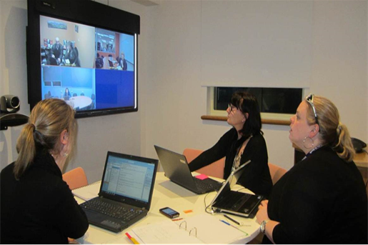

Courses available in 2018:
- Understanding Autism Spectrum Disorders
- Understanding Hearing Loss
- Understanding Dyslexia and Significant Difficulties in Reading
- Inclusion of Students with Speech, Language and Communication Needs

FURTHER INFORMATION:
Contact the Online Professional Learning Coordinator for your region for further information:

North-Western Victoria Region
Kellie Blair (03) 9488 9468

South-Western Victoria Region
Jacqui Nicholson (03) 5225 1028

North-Eastern Victoria Region
Pauline Cavalot (03) 8392 9332

South-Eastern Victoria Region
Emma Wray (03) 8765 5624

