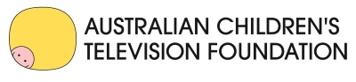
Content and Curriculum Resources
Available for Primary & Secondary Schools in FUSE

Victorian DET teachers and students have access to some of the best Australian-made children’s television and curriculum resources developed by the Australian Children’s Television Foundation in the FUSE portal. These include:

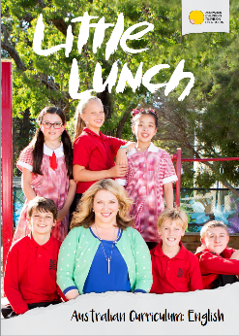
Little Lunch
A comedy mockumentary series that follows the dramas that occur at primary school during recess … or Little Lunch!
Available in FUSE
- All 26 episodes of TV series
- Literacy and cross-curricular resources
- Little Lunch App
- Cast & author webinars
Victorian Curriculum Areas: Civics and Citizenship, Critical and Creative Thinking, Drama, English, Ethical Capability, Health and Physical Education, Media Arts, Personal and Social Capability

Target Audience: The Little Lunch series is rated PG and is suitable for middle and upper primary students.
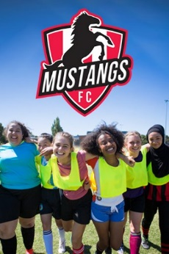
Mustangs FC
Comedy drama about teenage girls who are abandoning the sidelines to start their local football club’s first all-female team.

Available in FUSE
- All 13 episodes of TV series
- Teaching Toolkit Curriculum Resource
- Cast webinar
Victorian Curriculum Areas: Civics &Citizenship, Critical & Creative Thinking, Drama, English, Ethical Capability, Intercultural Understanding, Health & Physical Education, Media Arts, Personal & Social Capability

Target Audience: The Mustangs FC series is rated PG and is suitable for middle-years students.
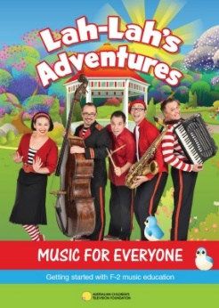
Lah-Lah’s Adventures – F-2 Music for Everyone
A music education resource for F-2 general classroom teachers who don’t necessarily have a music background.

Available in FUSE
- 43 music and tutorial video clips
- Literacy and cross-curricular resources
Victorian Curriculum Areas: Dance, Drama, English, Health and Physical Education, Media Arts, Music, Personal and Social Capability

Target Audience: The Music for Everyone resource is rated G and is suitable for early years and lower primary students.

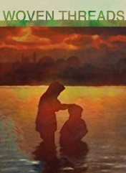
Woven Threads
Through beautiful and powerful animations Woven Threads presents eight varied and moving stories of refugees.

Available in FUSE
- All 8 episodes of the animated series
- Curriculum Resource
Victorian Curriculum Areas: Civics & Citizenship, Drama, Economics & Business, English, Ethical & Intercultural Capability, Geography, Health & Physical Education, History, Media Arts, Personal & Social Capability, Visual Arts
Target Audience: The Woven Threads series is rated PG and is suitable for middle years and senior secondary.

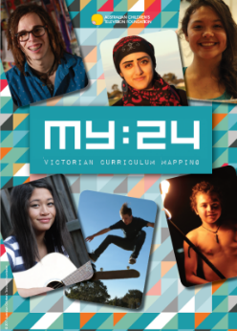
MY:24
26 young people from aroud Australia tell their story about the day that changed their lives forever in a series of short documentaries.

Available in FUSE
- All 26 episodes of the documentary TV series
- Curriculum Resource
Victorian Curriculum Areas: Civics and Citizenship, Critical and Creative Thinking, English, Ethical Understanding, Health and Physical Education, Humanities and Social Sciences, Intercultural Understanding, Personal and Social Capability
Target Audience: The MY:24 series is rated PG and is suitable for middle-years and senior secondary students.

