Making the Most of ACTF Content in FUSE
Full-Day Professional Learning Workshop for Secondary Teachers

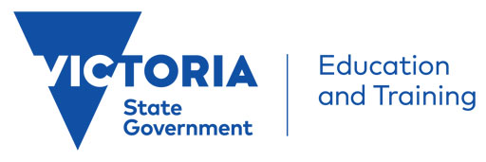
This hands-on workshop run by the ACTF Education Team will walk DET secondary teachers through how the ACTF resources in FUSE can be effectively used across the Years 7-12 curriculum. Content, resources and tools Mustangs FC, Woven Threads and MY:24 will be covered.
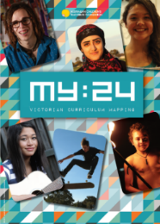
Teachers will explore how the ACTF content, curriculum resources and tools they have access to via FUSE could be used in the classroom and develop practical ideas to take back to their colleagues.

ACTF Primary Teacher Professional Learning Workshop Details
Dates: Friday, September 14
Venue: Australian Children’s Television Foundation
3rd Floor, 145 Smith St, Fitzroy 3065
Time: 9.30am – 3.00pm
Facilitators: Peter Maggs and Janine Kelly
Audience: Curriculum coordinators, general classroom teachers
Register: Sept 14 Secondary Workshop (Eventbrite link)
Eligibility: DET teachers (Limit of 2 teachers per school per workshop)

Victorian Curriculum Areas Covered:
Civics and Citizenship, Critical and Creative Thinking, Drama, English, Ethical Capability, Health and Physical Education, Media Arts, Personal and Social Capability

