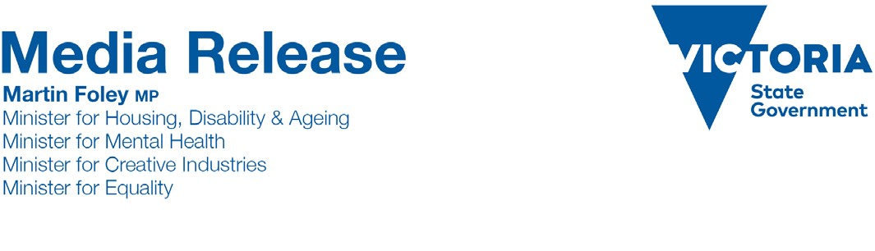
Friday, 30 June, 2017
NEW PROGRAM TO BRING CREATIVITY TO THE CLASSROOM AND BEYOND
The Andrews Labor Government is giving classrooms across Victoria access to the state’s leading creative practitioners, injecting creativity right across the curriculum.
Creative Learning Partnerships is a new program that will provide more opportunities for Victorian schools to tap into the strength of the state’s creative industries.
The program is an expansion of the Artists in Schools program, which saw Victorian artists work with students on projects ranging from theatre and dance performances to public sculpture projects.
While the new program still offers opportunities for schools to pair up with individual artists, it will also allow schools to engage with Victorian arts and creative organisations, which rank among the best in the world.
In addition to the residencies, the program will support the roll-out of partnerships using conferencing technology that will allow creative practitioners to be beamed live into the classroom, making creative opportunities more accessible to students in remote and regional schools.
This concept and technology was successfully piloted earlier this year, with a series of highly successful virtual creative residencies in schools including Tempy Primary School, a remote school in the Mallee with just 18 students.
Creative Learning Partnerships can involve professionals or organisations in any field of the creative industries, from the visual and performing arts through to design and digital games development.
Schools can apply for grants of $10,000 to work with a creative professional or $35,000 to partner with a creative organisation. Projects will take place over about 20 days, and can be aimed at students ranging from foundation through to Year 10.
Creative education is one of 40 action areas of the Labor Government’s $115 million Creative State strategy, which aims to put creativity at the heart of Victoria’s future.
A series of information sessions will take place across the Victoria in July. To find out more about the Creative
Learning Partnerships program, or to register for an information session, visit creative.vic.gov.au

Quotes attributable to Minister for Creative Industries Martin Foley
“Creative thinking will be a sought after skill for the jobs of the future and increasingly creativity is being employed to improve learning in areas such as maths, science, technology and more.”
“The Creative Learning Partnerships program expands on the programs of the past, and will provide students with more opportunities to learn from, and work alongside, some of the state’s most dynamic creative minds.”

Quotes attributable to Minister for Education James Merlino
"We need to teach our children to think critically and creatively to ensure they are ready for the jobs of the future.
That is why programs like this are so important."
Media Contact: Hayley McNaughton 0424 753 775| Hayley.mcnaughton@minstaff.vic.gov.au

