Making the Most of ACTF Content in FUSE
Full-Day Professional Learning Workshop for Primary Teachers

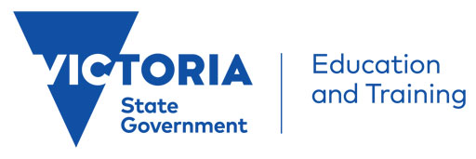

This hands-on workshop run by the ACTF Education Team, in partnership with the Victorian Department of Education and Training, will walk primary teachers through how the ACTF content in FUSE can be effectively used across the Years F-6 curriculum.

Content, resources and tools for Little Lunch, Mustangs FC, Lah-Lah’s Adventures – Music for Everyone, Woven Threads and MY:24 will be covered.

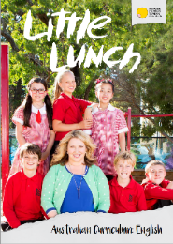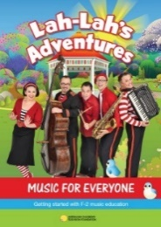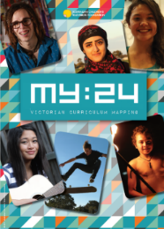

Teachers will explore how the high-quality ACTF content, curriculum resources and tools they have access to via FUSE could be used in the classroom and develop practical ideas to take back to their colleagues.

ACTF Primary Teacher Professional Learning Workshop Details
Dates: Friday, September 7 or Thursday, September 13
Venue: Australian Children’s Television Foundation
3rd Floor, 145 Smith St, Fitzroy 3065
Time: 9.30am – 3.00pm
Facilitators: Peter Maggs and Janine Kelly
Audience: Curriculum coordinators, general classroom teachers
Register: Sept 7 Primary Workshop or Sept 13 Primary Workshop (Eventbrite links)
Eligibility: DET teachers (Limit of 2 teachers per school per workshop)

Victorian Curriculum Areas Covered:
Civics and Citizenship, Critical and Creative Thinking, Drama, English, Ethical Capability, Health and Physical Education, Media Arts, Music, Personal and Social Capability

